The Red White and Blue:

Mrs Murphy revisited

The possible EU sector inquiry into premium rights

Context

At almost £300 million per season, in November 2013, BT paid more than double the current UK deals for the exclusive right to screen live Champions League matches from 2015. Both of the current rights owners, Sky and ITV, were reported as saying that they were unwilling to pay over the odds based on their business models. The BT Champions League deal follows a massive increase (71%) in the amount paid for the UK Premier League live broadcasting rights back in June 2013, in which BT played a part. But a recent communication regarding the EU’s competition directorate may call into question the EU law treatment of territorial premium content rights.

Licensing

The licensing of audiovisual content rights is typically conducted on a national basis to the extent that there is only a limited demand from bidders for global or pan-European rights; broadcasters usually operate on a territorial basis and serve the domestic market either in their own country or in a small cluster of neighbouring countries with a common language.[1]

Moreover, content licensing has traditionally been contracted on a territorially exclusive basis; licensees are granted absolute territorial protection regarding the licensed rights. As one commentator points out, territorial exclusivity has been broadly accepted in individual Member States:

“*In principle, under EU competition law, territorial restrictions fragmenting the EU internal market, such as absolute territorial protection, restrict competition by their very object (without the need to prove their effects). However, the jurisprudence and decisional practice concerning territorial exclusivity in the agreements between right holders (owners of premium content rights) and broadcasters has so far been limited and interpreted as allowing such absolute territorial protection.*” [2]

This stance was endorsed at the EU level by the landmark Coditel II case.[3]

Under well-established EU case law restrictions on the freedom to provide services can be justified if they pursue a legitimate objective, are justified by overriding reasons of public interest and are suitable for securing the attainment of that objective without going beyond what is necessary.

**Territorial exclusivity: Mrs Murphy and the Red White and Blue**

Then there was a challenge to the accepted thinking on exclusive territorial licensing in cases concerning pubs that bought foreign satellite decoders for screening live football matches. The Premier League sought to prevent the avoidance of the exclusive territorial licensing and brought actions against the Greek suppliers and their licensees.

A parallel case arose from an appeal against a criminal conviction in proceedings against Mrs. Murphy, the now infamous publican who showed Premier League matches in her pub using a Greek decoder card. What at first blush may have appeared to be a relatively straightforward case was ultimately a multi-layered complex legal scenario with a number of potentially wide-ranging outcomes. The issues raised straddle free movement of goods, competition law and copyright infringement as well as the criminal law.

The UK High Court referred various questions to the Court of Justice of the EU (‘CJEU’) relating to the compatibility of The Premier League’s licensing arrangements with EU law. These included questions relating to application of EU free movement rules and competition law. In October 2011, the CJEU provided a landmark ruling, stating, amongst others:

“*The Court of Justice holds that national legislation which prohibits the import, sale or use of foreign decoder cards is contrary to the freedom to provide services and cannot be justified either in light of the objective of protecting intellectual property rights or by the objective of encouraging the public to attend football stadiums.*”[4]

Ultimately Mrs. Murphy’s prosecution was quashed by the High Court in London. It was not a criminal offence to subscribe to a foreign decoder and to receive broadcasts from outside the UK using that decoder and the restrictions on the use of such decoders were unlawful under EU free movement principles. She was therefore free to continue subscribing to Greek pay TV retailer Nova TV for broadcast Premier League matches via its decoder.

But she was not permitted to show the broadcasts in her pub as they would have breached the limited copyright the Premier League has, namely any opening video sequence, the Premier League anthem, pre-recorded films showing highlights of recent Premier League matches and various graphics.

The CJEU considered that the EU rules on free movement (specifically Article 56 TFEU) precluded national legislation that made it unlawful to import and sell foreign decoding devices.[5] This restriction could not be justified by the objective of protecting IP rights. It further ruled that the grant of exclusive satellite broadcasting licences for the territory of a Member State or states and which required the licensee not to supply decoding cards to enable viewing outside the territory restricted competition within Article 101(1) TFEU.

On 22 November 2013, the Financial Times reported that the European Commission is set to launch a formal investigation into sales of pay-TV rights, quoting a short paragraph from a Commission communication published in May 2013:

“*whether licensing agreements for premium pay-TV content contain absolute territorial protection clauses which may restrict competition, hinder the completion of the single market and prevent consumers from cross-border access to premium sports and film content*…”[6]

The context or impetus for the Commission comment in the document is that following the Murphy decision, it had conducted a preliminary fact-finding investigation to examine licensing agreements. We observe that DG Competition categorises “*sport rights, music, popular films, etc.”* as premium content.

The comment by the judge in Murphy that there were wider legal issues to explore (and not least the delicate relationship with copyright) is expected to lead to a wider inquiry at EU level. Such an inquiry may presumably take the form of an EU sector inquiry or similar which permits the Commission to undertake an inquiry into a sector even where it does not suspect wrongdoing by individual companies. As stated in Article 17 of Regulation 1/2003 such inquiries are within the Commission’s remit. In particular:

“*Where the trend of trade between Member States, the rigidity of prices or other circumstances suggest that competition may be restricted or distorted within the common market, the Commission may conduct its inquiry into a particular sector of the economy or into a particular type of agreements across various sectors*.”[7]

A principal question to ask is, why now? While there are no further comments from the Commission available in the public domain (save the one referenced at footnote 6), it is assumed that the judgment in the Murphy case was a catalyst. And some preliminary fact-finding will have been necessary to justify opening the case. Moreover, it is worth noting that it is over four years since the Commission concluded its pharmaceutical sector inquiry in July 2009 after a probe of some 18 months. It is understandable that it may want to avoid too precipitous a probe to fend off the criticism in the pharmaceutical sector inquiry that a disproportionate amount of time was spent in basic fact-gathering.

As stated above, the Murphy case entailed a complex array of legal issues but it signals what appears to be a move away from the comfort of the previous case law enshrined in *Coditel* and a reassertion of a clear focus on the free movement of goods and services.

Moreover, further complexities may arise owing to individual Member State investigations and competition cases (such as Ofcom’s pay TV investigation and the Competition Commission’s movies on pay TV investigation). It cannot go unnoticed that in the UK’s probe into premium movies, the Competition Commission concluded that Sky did not enjoy such an advantage over its rivals as to adversely affect competition in the pay TV retail market.[8]

**What does a Commission sector inquiry entail?**

EU sector inquiries typically begin with an announcement (although in the pharmaceutical sector inquiry the Commission launched its inquiry with dawn raids) and the following process is invoked:

* Information requests sent to interested parties, suppliers, customers and the Member States.
* Preliminary findings issued followed by a consultation on the findings and proposed action (if any).
* Assessment of further information and a final report is issued.
* Standalone competition law investigations may be opened if the Commission believes that there has been an infringement of competition law; it may recommend other parties (e.g. Member States) to take action.

A brief overview of previous Commission sector inquiries is provided in Figure 1.

**Figure 1: overview of Commission sector inquiries**

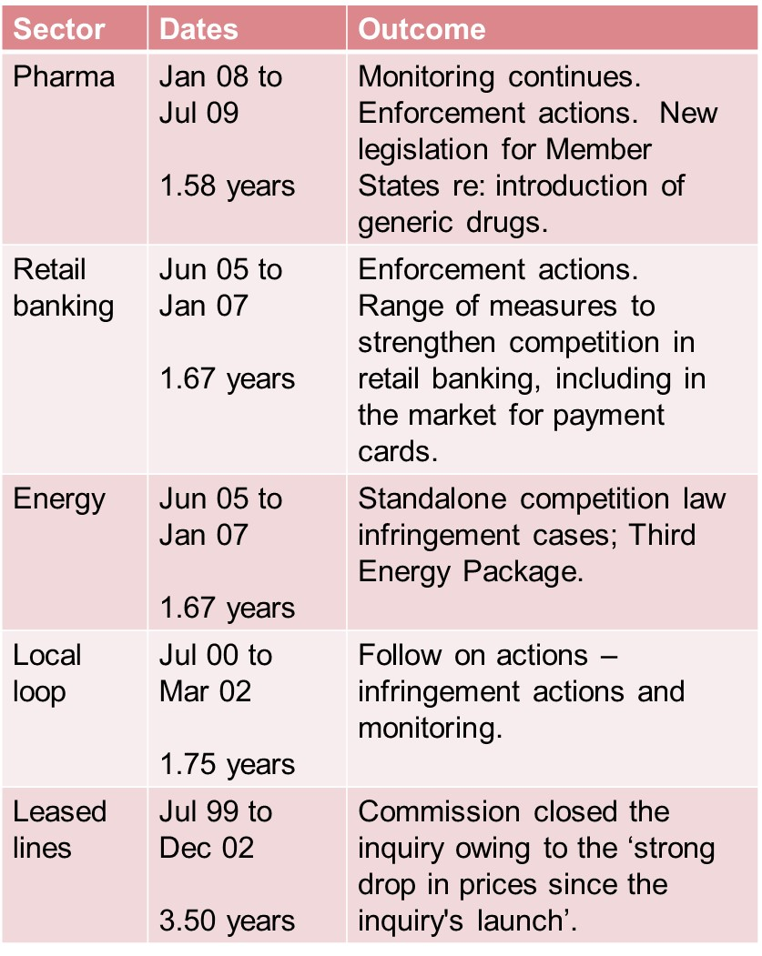

While at a high level (each inquiry was both detailed and nuanced), key takeaways are:

* A sector inquiry requires disclosure of vast amounts of information by affected companies, even if they are not the main focus of inquiry.
* Since an inquiry may last well over a year, this inevitably presents challenges for ‘business as usual’ during the period of regulatory uncertainty and a consequent burden on management time. The Commission aims to resolve such inquiries in 18 months but previous inquiries have lasted at least that time or longer.
* On the other hand, a sector inquiry may allow for the industry case to be more effectively presented and heard if the process is properly managed.

As such, even though a sector inquiry is different from a competition investigation into a possible infringement of competition law it should be treated with no less seriousness.

In Figure 2 we provide a summary of potential (generic) outcomes of an EU sector inquiry.

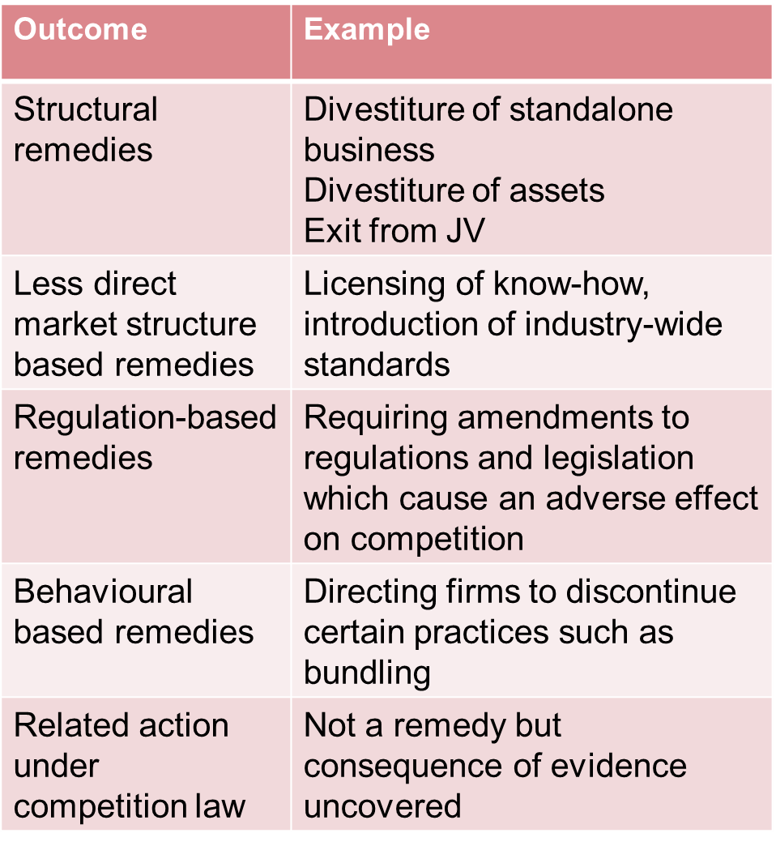**Figure 2: potential outcomes of an EU sector inquiry**

This demonstrates that:

* The outcomes of sector inquiries are potentially wide ranging from a clean bill of health to a follow on investigation under competition law. Indeed many of the abuse of dominance investigations in the energy sector were sparked by or coincided with the energy sector inquiry (2005-2007).
* However, the Commission has no power to apply intrusive remedies such as mandated divestments unless an infringement of competition law is found (unlike the Competition Commission or its successor the Competition and Markets Authority (“CMA”) in the UK.[9] Nevertheless, the Commission may make recommendations to other bodies or even national authorities to take effective action where they are better placed to deal. For example, in the pharma inquiry the Commission urged wider reforms in relation to an EU Patent, a reform thought by many to be overdue.

**What are the implications for this inquiry?**

The recent Premier League and Champions League live broadcast rights auctions have led to the signing of numerous new contracts. We do not have access to their detail and thus cannot form a view as to whether amendments were made following the Murphy judgment.

Rights to certain live football matches tend to be high value in monetary terms and for the viewers, a matter of life and death for many (recalling the famous Bill Shankly quote). However, they are but one sub-genre within the broader sports genre. There’s the other sports, and further genres beside – ‘music, popular movies etc.’ – to quote the Commission. Multiply the number of rights holders by genre and licensees within Member States and it is clear that any industry inquiry (if all-embracing) is potentially enormous in scale and scope.

Moreover, each genre/sub-genre has its own specific economics and characteristics. The economics of Hollywood movies and their temporal multi-format release channels – or windows – contrasts significantly to many other forms of content. The packaging of content is also important – content has to be made specific to suit each particular territory. In addition to marketing and promotion, there is possible adaptation to each relevant population on the basis of cultural and linguistic specifics. Such costs are not negligible.

And don’t forget about online – it is conceivable that geo-blocking will be an issue of focus, particularly following the Commission’s ‘Licences for Europe’ stakeholder dialogue. This resulted in, amongst others a pledge for the further development of cross-border portability of subscription services. And we must not dismiss the CJEU’s focus on the importance of the free movement of goods and services in the internal market.

While the actual scope and focus of the inquiry remains to be seen, a number of issues have been flagged by the Commission in its comments so far. It has earmarked that the following issues are likely to be examined, namely, whether the relevant licensing agreements contain clauses which may:

* restrict competition between Member States;
* hinder the effective operation of the single market; and
* unduly prevent EU consumers from accessing premium sports and film content across EU borders.

We consider each in turn.

Restriction of competition

An agreement falls within the prohibition laid down in Article 101(1) TFEU when it has as its object or effect the prevention, restriction or distortion of competition.

In the Murphy case, the CJEU stated:

“*it is apparent from the Court’s case-law that the mere fact that the right holder has granted to a sole licensee the exclusive right to broadcast protected subject-matter from a Member State, and consequently to prohibit its transmission by others, during a specified period is not sufficient to justify the finding that such an agreement has an anti-competitive object (see, to this effect, Case 262/81 Coditel and Others (‘Coditel II’) [1982] ECR 3381, paragraph 15).*”[10]

However, any comfort given to rights holders and broadcasters that the principles enunciated in Coditel remained unaffected was short-lived. Several paragraphs later the CJEU stated that:

“…*a premium is paid to the right holders concerned in order to guarantee absolute territorial exclusivity which is such as to result in artificial price differences between the partitioned national markets. Such partitioning and such an artificial price difference to which it gives rise are irreconcilable with the fundamental aim of the Treaty, which is completion of the internal market. In those circumstances, that premium cannot be regarded as forming part of the appropriate remuneration which the right holders concerned must be ensured*.”

“*Consequently, the payment of such a premium goes beyond what is necessary to ensure appropriate remuneration for those right holders*.”[11]

And in conclusion:

“*Accordingly, given that those clauses of exclusive licence agreements have an anticompetitive object, it is to be concluded that they constitute a prohibited restriction on competition for the purposes of Article 101(1) TFEU.*”[12]

The CJEU considered that agreements that aimed to partition markets according to national borders or made cross-border supply more difficult must be regarded as agreements whose object is to restrict competition.

It appears from the judgment that it is not the exclusive licences themselves that are being challenged as restrictive by object but the requirements on broadcasters not to supply devices that would enable supply outside the territory. This latter requirement is the basis of absolute territorial exclusivity which is the apparent nub of the CJEU’s concern. The CJEU considered that such clauses would not meet the conditions of individual exemption under Article 101(3) TFEU since they would go beyond what was necessary to protect the underlying IP rights.

However, Article 101(3) was not raised before the national court. In the authors’ view, the issue of compatibility with Article 101(3) will inevitably be testing ground for further inquiries which by their nature will be fact-based. One thing is sure, however, is that the CJEU’s pronouncements as to such clauses being restrictive by object raises the burden on rights holders to justify their arrangements under Article 101(3).

Hindering the completion of the single market

There is some overlap between the CJEU’s reasoning in relation to free movement and competition issues. The crux of the matter from the perspective of free movement is whether the restriction on free movement so identified is objectively justified. In the pub cases the CJEU rejected the objective of the protection of IPR and the objective of encouraging the public to attend football stadiums as adequate justification. In so doing it has forced the question as to whether the hitherto accepted economic justifications for the current premium rights licensing models still hold. In short, it has forced a rethink into the underlying economics of the industry.

Prevention of consumers from cross-border access to premium sports and film content

The CJEU cast doubt about the legality under competition law and free movement law of restrictions in exclusive licensing that provide absolute territorial protection for broadcasters by preventing consumers in one Member State from acquiring devices to allow them to view broadcasts from another Member State. As such, it may be considered a partial victory for consumers who buy such equipment across borders. A prime example is expats who like to view their favourite domestic TV shows once abroad.

And this is of course where online enters the fray. Consider all the frustrated Brits on holiday abroad during the summer of 2012, unable to watch the Olympics on the BBC iPlayer. The Licences for Europe stakeholder dialogue resulted in a pledge by the audiovisual industry to increase gradually the cross-border portability of subscription-based audiovisual services. The status of this initiative at the time of the inquiry, will play a key part in the extent to which the Commission delves deeper into online cross-border issues.

It is unclear as to whether music will fall under the scope of the inquiry. A question arises as to the extent to which such content could be considered ‘premium’ – if indeed any EU inquiry is limited to such. Whatever the scope of inquiry, it is likely that any examination of the EU rules on exclusive licensing on a territorial basis will not go unnoticed by players in other or related sectors where such practices are common. In a different context the European Commission’s inquiry into the licensing practices of collective societies in the CISAC case has emphasised that the delicate balance between competition, copyright and fee movement remains an ongoing policy priority.

On 12 April 2013, the General Court gave judgment in appeals brought by CISAC and its collecting society members against the Commission’s decision in 2008 finding that the societies had infringed Article 101(1) TFEU through their reciprocal representation agreements.[13] Although the General Court ruled that the Commission had not established evidence of a concerted practice between the societies as to the terms of their agreements it dismissed appeals against the Commission decision finding that the individual provisions in the agreements were in fact contrary to Article 101(1) TFEU.[14]

**What next?**

What are the likely implications of the sector inquiry for stakeholders? Some serious issues are sure to be raised. For example, may there be a wholesale change to future content licensing deals? May the economics of the various content genres be significantly undermined? To what extent will DG Competition take into consideration possibly nuanced audiovisual-specific (and policy) factors?

Rights holders, broadcasters and licensees all have a stake in the inquiry and will need to assess where their interests lie. Those facing complaints or investigations domestically will also need to ensure consistency of messaging. The key drivers of the inquiry will likely be the strength of complaints, the coherence of arguments and the evidence presented. While an ostrich-like strategy may be warranted for a peripheral player, such players may want to consider whether there are opportunities from more active participation.

Among the issues to consider are:

* Development of the business' regulatory strategy and how this impacts on commercial decision-making (licence fees, renewals etc.).
* Case-making and submission to the Commission and other bodies.
* Evidence assembly in relation to the above.

Whatever the focus of the inquiry, interesting questions arise as to its relevance to licensing of audiovisual rights more generally. At this stage it may be premature to predict the way in which the inquiry might unfold. Important issues for determination will include:

* Whether and to what extent music is covered.
* The relationship between online access and cross-border access. The commitments made in the recent Licences for Europe initiative may provide a sufficient level of comfort in some areas (e.g. cross-border access to online live streaming of live and catch-up domestic broadcasts for consumers when they go overseas).
* The extent to which the economics of different sectors dictate a different treatment. In the Murphy case, the CJEU expressed concerns about partitioning national markets, “*such as to result in artificial price differences between the partitioned national markets. Such partitioning and such an artificial price difference to which it gives rise are* *irreconcilable with the fundamental aim of the Treaty … that premium cannot be regarded as forming part of the appropriate remuneration which the right holders concerned must be ensured*”. An important first step will be to demonstrate the economics of the movie value chain and the nature of licensing policies vis-à-vis individual territories.
* The Premier League cases concerned premium sporting rights. The traditional rationale for territorial licensing is based on the different risks inherent in penetrating different territories. The CJEU accepted that the objective of protecting intellectual property rights could be a relevant justification for restrictions on free movement but only appropriate remuneration is accepted. The CJEU considered that the restrictions in issue went beyond what was necessary.

|  |  |
| --- | --- |
|  |  |
|  |  |
| **Contact details** |  |
| Dr. Alison Sprague  Partner, CEG Europe  One Fetter Lane  London EC4A 1BR  United Kingdom  T / +44 (0)20 3440 5526  M / +44 (0)75 0784 0740  E / asprague@ceg-europe.com  www.ceg-europe.com | Suzanne Rab  Barrister, Serle Court  6 New Square  Lincoln’s Inn  London WC2A 3QS  United Kingdom  T / +44 (0)20 7242 6105  D / +44 (0)20 7400 7117  M / +44 (0)75 5704 6522  E / srab@serlecourt.co.uk  www.serlecourt.co.uk |

Interesting issues arise as to whether a particular pricing model is justified by reference to the economic value of the services provided. In the case of broadcasting this may be measured in terms of the size of the audience. Where high returns are not guaranteed, rights holders and licensees (including putative licensees) will want to argue their case as to why a particular business model is or is not justified.

**How may we assist**

We are able to assist you in preparing your response to the forthcoming inquiry as follows:

* Helping you to develop the strategic response to the inquiry, including advice on the appropriate ‘lines to take’ with the Commission.
* Collating evidence in support of specific licence pricing policies.
* Developing the appropriate counterfactual and approach to benefits/efficiency/economic arguments.

Please get in touch if you would like to discuss the issues raised in this paper.

*Any opinions expressed in this communication are personal and are not attributable to Competition Economists Group LLP*

Alison Sprague

*Dr. Alison Sprague is a partner in CEG’s London office. She has more than 15 years’ economics consulting experience and specialises in the media, entertainment and telecoms sectors, advising private and public sector clients. Her sector experience includes television, radio, film, internet, music, sport, gambling, music, publishing and fixed/mobile telecoms. She has led numerous strategy and economics projects, providing commercial, competition, policy and regulatory advice. She has additionally conducted research into brands and advertising effectiveness and led a number of expert witness reports. Several projects have employed econometric techniques. Clients comprise leading broadcasters; pay TV retailers, and telcos; trade associations; regulators, government departments, and their legal advisers, in the UK and overseas (including the EU, Eastern Europe, South Africa, Russia, India, Hong Kong). Alison has written numerous thought leadership papers - on media plurality (in the UK and Australia), local newspapers, government media policy, copyright, gambling, future business models for fixed and mobile internet, mobile markets in the EU, consumer policy and the competition regime in the UK.*

Alison has expertise in advertising revenue forecasting gained in numerous successful franchise applications and renewals and cases covering competition, deregulation, litigations, due diligence, and privatisation. She has also examined funding models, public value and economic impact in relation to public service broadcasters, assessed possible uses, values and bidders for the UK’s ‘digital dividend’ (UHF) spectrum, and examined the likely impact of changing the amount of permitted advertising minutage on TV.

She conducted two major studies of pay TV markets in the EU as input to a client’s submission to Ofcom’s pay TV investigation. Other competition experience includes a merger in the Netherlands TV market, EU roaming charges, UK transport pricing, the collective selling of UK sports rights, UK newspaper and magazine distribution, EU and UK fixed-to-mobile termination rates, the UK outdoor advertising sector, EU local loop and leased lines, and GSM spectrum in the Netherlands. She recently appraised international media plurality and competition regimes as input to a regulatory response on behalf of a major satellite industry association. She has additionally examined sports rights including an estimation of the implicit value of the rights to the Champions League in terms of advertising and sponsorship revenue, an analysis of the Premier League’s revenue distribution model, an assessment of the regulatory and competition issues in respect of the Premier League’s next sale of its broadcast rights, and reviewed an expert report regarding the collective selling of football rights following an investigation by the OFT.

Many of the studies she has led have been published, including: the BBC’s educational activities for the BBC Trust; the European pay TV sector in support of client submissions to Ofcom’s pay TV investigation; advertising effectiveness; the economic impact of the BBC, how Ofcom takes into account the consumer interest in its regulatory processes; the assumptions underpinning the reach projections for the BBC iPlayer; measuring media plurality on behalf of News Corporation, and a report for Ofcom on the commercial viability of local TV.

Alison has three degrees in economics. She was Research Assistant to Professor Patrick Minford and her M.Phil and D.Phil theses supervisor was Professor Stephen Nickell. She was also a college lecturer at Oxford University. Prior to joining CEG, she held positions at FTI, PwC, KPMG and NERA. She is a member of the IAB’s Future Trends Working Group and is co-author with Suzanne Rab of "Media Ownership and Control: Law, Economics and Policy in an Indian and International Context" (forthcoming in Hart Studies in Competition Law in 2014).

Suzanne Rab

*Suzanne is a barrister specialising in competition law at Serle Court, a leading chambers based in Lincoln’s Inn. Suzanne has wide experience of EU law and competition law matters combining cartel regulation, commercial practices, IP exploitation, merger control, public procurement and State aid.*

*Suzanne advises in relation to a wide range of industry sectors, with a focus on industries that are subject to sector-specific regulation. Suzanne has advised on a considerable range of competition law and regulatory issues in the converging communications and media sector including in matters relating to telecoms, online distribution, pay TV, newspapers, sports rights and licensing of copyright.*

In the telecoms sector, she has advised a UK mobile operator on the licensing, competition and regulatory aspects of the UK Competition Commission’s investigation into termination charges. At EU level, she has advised on the European Commission’s competition investigation into differential pricing of iTunes in the EU Member States. She has also been engaged to advise on the EU and UK competition law, regulatory and merger control issues relating to Video-on-Demand. In the print media, Suzanne’s representative engagements include advising a UK investor on the competition law and public interest aspects of its proposed investment in a major UK newspaper quality title and a regional newspaper on the competition law implications of its distribution arrangements. Suzanne has advised at the cutting edge of media plurality issues including advising News Corporation on the UK and EU competition law and public interest aspects of its proposed acquisition of the shares in British Sky Broadcasting Group that it does not already own. In the audio-visual sector, she has advised a range of players from start-ups to major content owners and broadcasters. Suzanne has advised extensively on the intersection between intellectual property and competition law in communications, and media and technology cases. Suzanne has wide experience of advising business, governments, regulators and governments on the design and implementation of new laws and regulatory regimes in line with international best practices, including in telecoms and network industries.

|  |  |
| --- | --- |
|  |  |

In private practice as a solicitor for 15 years prior to joining the bar, she has held positions at magic circle and leading international antitrust practices. Most recently she was an antitrust partner with a leading international practice. She has also held the role of director at PricewaterhouseCoopers working within its strategy, economics and forensics teams.

Suzanne is also co-author with Alison Sprague of "Media Ownership and Control: Law, Economics and Policy in an Indian and International Context" (forthcoming in Hart Studies in Competition Law in 2014).

1. In contrast, demand for music licensing is often much wider than national e.g. from iTunes.
2. OECD Roundtable on Competition Issues in Television and Broadcasting, contribution submitted by the services of the European Commission, Directorate-General for Competition; p 92. See*:*  http://www.oecd.org/daf/competition/TV-and-broadcasting2013.pdf
3. Case 262/81 Coditel SA and others v Ciné-Vog Films SA and others [1982] ECR 3381. Available at: http://eur-lex.europa.eu/LexUriServ/LexUriServ .do?uri=CELEX:61979CJ0062:EN:PDF
4. Judgment of the Court, Joined Cases C‑403/08 and C‑429/08. Available at: http://curia.europa.eu/juris/document/document.jsf?text=&docid=110361&pageIndex=0&doclang=EN&mode=req&dir=&occ=first&part=1&cid=20618
5. TFEU refers to the Treaty of the Functioning of the European Union.
6. See:Commission Staff Working Document accompanying the report from the commission on Competition Policy 2012 at: http://eur-lex.europa.eu/LexUriServ/LexUriServ.do?uri= SWD:2013: 0159:FIN:EN:HTML
7. DG Competition web page outlining the media sector. Available at: http://ec.europa.eu/competition/sectors/media/overview_en.html
8. Although we note that this inquiry was not focused on absolute territorial protection, not least given its domestic remit.
9. The CMA replaces the UK’s first stage and second stage competition authorities with effect from 1 April 2014.
10. See: Para 137, Judgment of the Court, Joined Cases C‑403/08 and C‑429/08. Available at: http://curia.europa.eu/juris/document/document.jsf?text=&docid=110361&pageIndex=0&doclang=EN&mode=req&dir=&occ=first&part=1&cid=20618
11. Ibid.
12. Ibid.
13. CEG advised one of the parties in the CISAC case.
14. [Case T-392/08 - AEPI v Commission](http://curia.europa.eu/juris/documents.jsf?num=T-392/08), [Case T-398/08 - Stowarzyszenie Autorów "ZAiKS" v Commission](http://curia.europa.eu/juris/documents.jsf?num=T-398/08), [Case T-401/08 - Säveltäjäin Tekijänoikeustoimisto Teosto v Commission](http://curia.europa.eu/juris/documents.jsf?num=T-401/08), [Case T-410/08 - GEMA v Commission](http://curia.europa.eu/juris/documents.jsf?num=T-408/08), [Case T-411/08 - Artisjus Magyar Szerzõi Jogvédõ Iroda Egyesület v Commission](http://curia.europa.eu/juris/documents.jsf?num=T-411/08), [Case T-413/08 - SOZA v Commission](http://curia.europa.eu/juris/documents.jsf?num=T-413/08), [Case T-414/08 - AKKA/LAA v Commission](http://curia.europa.eu/juris/documents.jsf?num=T-414/08), [Case T-415/08 - IMRO v Commission](http://curia.europa.eu/juris/documents.jsf?num=T-415/08), [Case T-416/08 - EAU v Commission](http://curia.europa.eu/juris/documents.jsf?num=T-416/08), [Case T-417/08 - SPA v Commission](http://curia.europa.eu/juris/documents.jsf?num=T-417/08), [Case T-418/08 - OSA v Commission](http://curia.europa.eu/juris/documents.jsf?num=T-418/08), [Case T-419/08 - LATGA-A v Commission](http://curia.europa.eu/juris/documents.jsf?num=T-419/08), [Case T-420/08 - SAZAS v Commission](http://curia.europa.eu/juris/documents.jsf?num=T-420/08), [Case T-421/08 - Performing Right Society v Commission](http://curia.europa.eu/juris/documents.jsf?num=T-421/08), [Case T-422/08 - Sacem v Commission](http://curia.europa.eu/juris/documents.jsf?num=T-422/08), [Case T-425/08 - KODA v Commission](http://curia.europa.eu/juris/documents.jsf?num=T-425/08), [Case T-428/08 - STEF v Commission](http://curia.europa.eu/juris/documents.jsf?num=T-428/08), [Case T-432 - AKM v Commission](http://curia.europa.eu/juris/documents.jsf?num=T-432/08), [Case T-433/08 SIAE v Commission](http://curia.europa.eu/juris/documents.jsf?num=T-433/08), [Case T-434/08 - TONO v Commission](http://curia.europa.eu/juris/documents.jsf?num=T-434/08), [Case T-442/08 - CISAC v Commission](http://curia.europa.eu/juris/documents.jsf?num=T-442/08) and [Case T-451/08 - Stim v Commission](http://curia.europa.eu/juris/liste.jsf?language=en&num=T-451/08)