www.serlecourt.co.uk PROPERTY SerleShare


Council remained in breach of that duty until 2018 when the remediation scheme was carried out. In applying the “but for” test the Court held that the Council’s breach of duty between 2013 and 2018 had not increased or materially contributed to the diminution in value of Mr Davies’ land. The loss had occurred many years before and on the evidence, well before 2004 and before any duty of care in private nuisance was owed by the Council to Mr Davies.

Lessons to be learned?
The first is that causation must never be overlooked in tort claims, particularly those in private nuisance, where the damage can occur years before a duty of care is owed. Secondly, Davies was about diminution in the value of Mr Davies’ property. It was not about damages for the cost of abatement of the nuisance while the duty of care was owed. That distinction was drawn by the Court in Davies from the judgment of the House of Lords in Delaware Mansions Ltd. v Westminster City Council [2002] 1 AC 321, which concerned the latter claim. Finally, it is yet another

Davies v Bridgend County Borough Council.
What a Nuisance!


Three in a row.
Like the proverbial London bus which tends to travel in the close company of its relations, in 15 months we have had three judgments from by the Supreme Court on the law of private nuisance. The first concerned the private nuisance claim brought by the lessees of flats being overlooked by visitors on the viewing platform to the Tate Modern gallery; Fearn v Board of Trustees of the Tate Gallery [2024] AC 1: 1st February 2023. The second judgment was delivered by the Court in Jalla v Shell International Trading and Shipping Co. Ltd. [2023] 2 WLR on 10th May 2023. That case concerned liability for oil pollution off the coast of Nigeria. It is important on a question of limitation of claims where the nuisance is a continuing one. Finally, on 8th May 2024 the Supreme Court handed down its judgment in Davies v Bridgend County Borough Council: [2024] UKSC 15: “Davies”.

Japanese Knotweed.
Davies was all about liability for knotweed and the effect it had on the value of Mr Davies’ property. By the time the claim for damages was
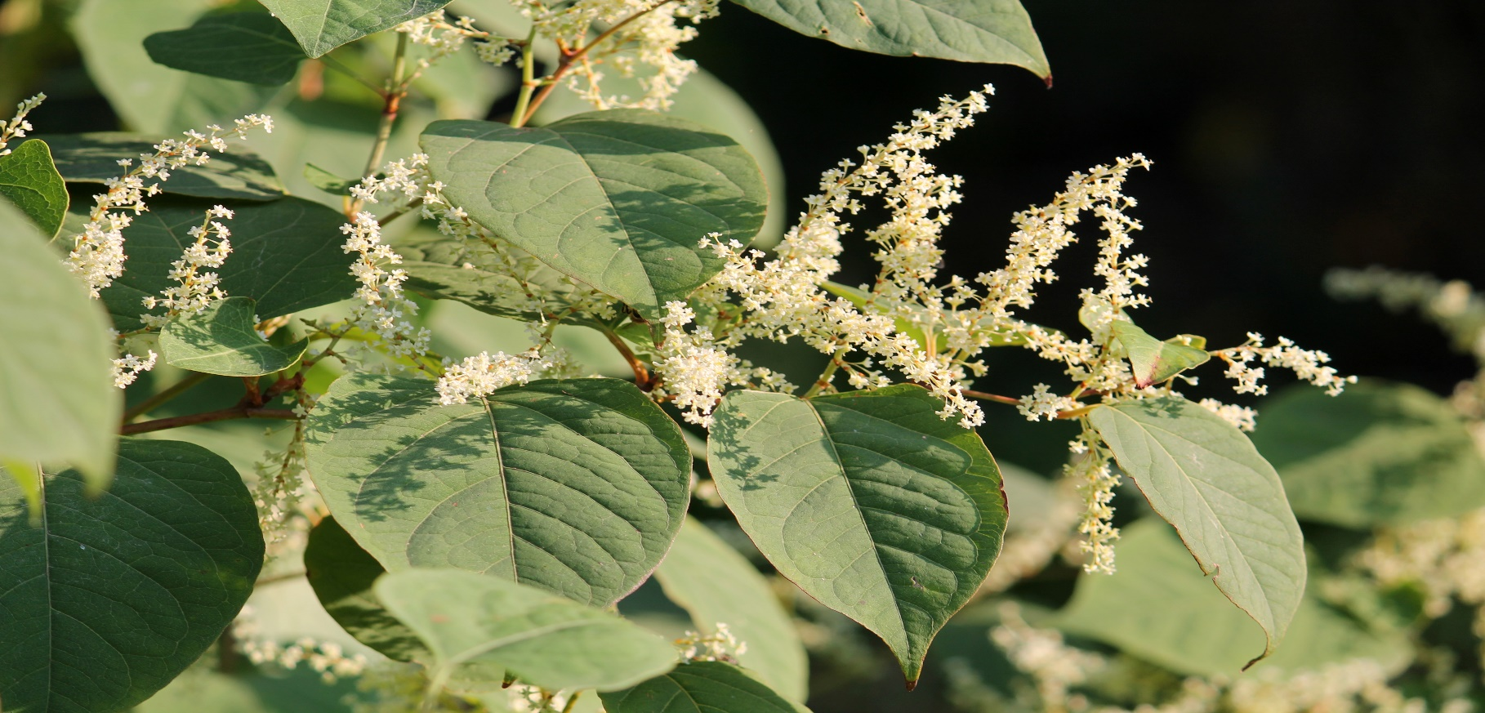

brought in 2020 the knotweed coming from the Council’s (former railway) land had been managed, but not eradicated, on his property. The “stigma” of its presence caused a residual diminution in value of his property of £4,900. That was the sole head of claim. The question before the Supreme Court was a narrow one. Was that diminution in value caused by the Council's breach of duty in private nuisance? The Supreme Court said “no”.

Causation was the key.
The answer to why the Court said “no” turned on dates. It was established that well before 2004 and prior to Mr Davies’ acquisition of his property that year, the knotweed had encroached onto it. At that date the Council was unaware of the encroachment. Its duty of care in private nuisance arose in 2013 when it became aware (or ought to have been aware because of the publication by the RICS of its “information paper” on knotweed in 2012) of the risk to Mr Davies’ property. The

example of the effect in legal terms of the presence of knotweed and other (more invasive) plants such as Giant Hogweed.



Serle Court.
9th May 2024.
© Andrew Francis.

Andrew Francis
Barrister
Andrew Francis
Barrister

